# Product Performance Analysis:

Products categorized under **Clothing**, **Electronics**, and **Grocery**, showing their quantity sold and revenue generated. The visualized chart helps correlate sales volume and revenue distribution across these categories.

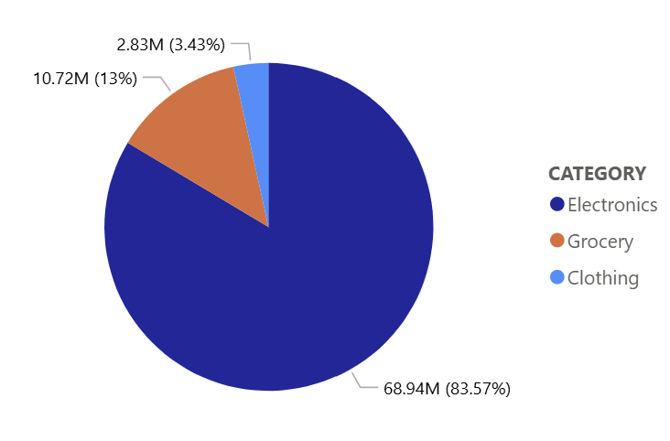

**Revenue Share Pie Chart**

**Clothing** has a revenue share of **2.83 M** which is **3.43%** of Total Revenue

**Groceries** have a revenue share of **10.72 M** which is **13%** of Total Revenue

#### **Electronics** has a revenue share of **68.94 M** which **83.57%** of Total Revenue

## **Category-wise Performance**

### **Clothing**

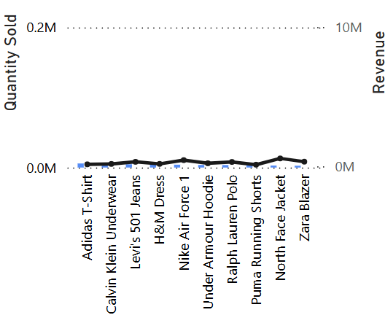

**Figure: 1**

* **Top Sellers by Quantity:**
  + **Adidas T-Shirt** – 5,817 units
  + **Calvin Klein Underwear** – 5,280 units
  + **Levi’s 501 Jeans** – 4,663 units
* **Top Revenue Earners:**
  + **North Face Jacket** – $568,371.58
  + **Nike Air Force 1** – $447,260.00
  + **Levi’s 501 Jeans** – $324,078.50
* **Insights:**
  + Despite lower unit sales, premium clothing like the **North Face Jacket** generates high revenue.
  + Most clothing products generate moderate revenue, suggesting a mid-range pricing strategy

### 

### **Electronics**

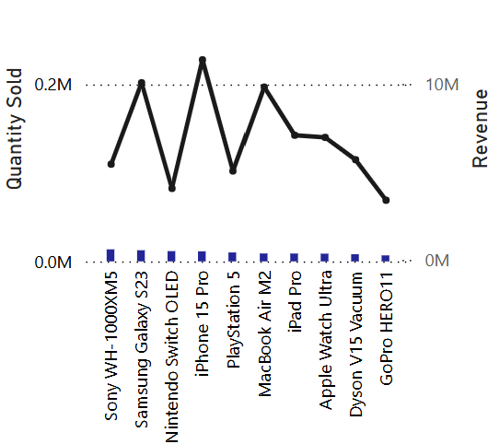

**Figure: 2**

* **Top Sellers by Quantity:**
  + **Sony WH-1000XM5** – 13,598 units
  + **Samsung Galaxy S23** – 12,584 units
  + **Nintendo Switch OLED** – 11,604 units
* **Top Revenue Earners:**
  + **iPhone 15 Pro** – $11,370,618.00
  + **Samsung Galaxy S23** – $10,067,074.16
  + **MacBook Air M2** – $9,820,664.00
* **Insights:**
  + Electronics dominate in revenue despite having lower unit sales than grocery.
  + **Apple and Samsung products** clearly lead in high-margin electronics.

### **Grocery**

### 

**Figure: 3**

* **Top Sellers by Quantity:**
  + **Bananas (1lb)** – 211,019 units
  + **Organic Whole Milk** – 198,230 units
  + **Eggs (Dozen)** – 186,735 units
* **Top Revenue Earners:**
  + **Ground Coffee** – $1,093,471.45
  + **Chicken Breast** – $1,107,118.50
  + **Coca-Cola 12pk** – $1,039,161.36
* **Insights:**
  + Grocery items have the highest volume but comparatively lower revenue per unit.
  + Staples like **Bananas** and **Eggs** lead in quantity but not in revenue due to low pricing.
  + Beverages and meats contribute more to grocery revenue.

### **Cross-Category Observations**

* **iPhone 15 Pro** is the top revenue generator overall at **$11.37M**, followed by **Samsung Galaxy S23** and **MacBook Air M2**.
* Grocery items dominate in volume, with **3 products over 100K units**, but electronics dominate in total revenue.
* Clothing has more variety but lags behind in both revenue and volume compared to other categories.

### **Visual Chart Insights**

* The bar chart confirms that **Grocery** dominates in volume (orange bars), while **Electronics** (blue bars) yield the most revenue (black line).
* The significant spike in revenue aligns with products like **iPhone 15 Pro**, **Samsung Galaxy S23**, and **MacBook Air M2**, all of which have relatively lower unit sales but very high price points.

### **Conclusion**

The data suggests a clear segmentation:

* **Electronics** are **high-margin**, **low-to-moderate volume**.
* **Groceries** are **high-volume**, **low-margin**.
* **Clothing** sits between the two, offering variety with mid-level performance.

To maximize profitability, focusing on expanding high-margin electronics while improving pricing strategy for grocery staples may be beneficial.

## **Pricing Strategy & Product Positioning**

The scatter plot (bubble chart) provides a multidimensional view of each product by simultaneously considering:

* Unit Price (X-axis)
* Quantity Sold (Y-axis)
* Revenue Generated (Bubble Size)

This visualization is particularly useful for identifying revenue efficiency and strategic positioning of each product in the market.

### **Key Observations**:

1. **High-Volume, Low-Price Products (Top Left)**Products such as Bananas, Eggs, and Organic Whole Milk dominate in quantity but have smaller bubbles, meaning they contribute modestly to revenue. These are essential grocery items with high turnover and low margins.

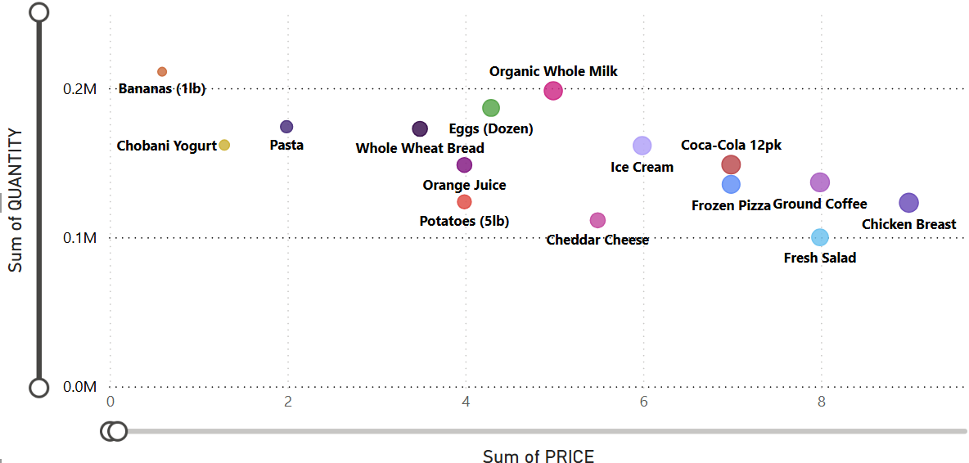

**Figure: 4**

1. **Low-Volume, High-Price Products (Bottom Right)**Products like the iPhone 15 Pro, MacBook Air M2, and iPad Pro lie at the bottom right with the largest bubbles. These generate high revenue from premium pricing despite moderate sales volumes.

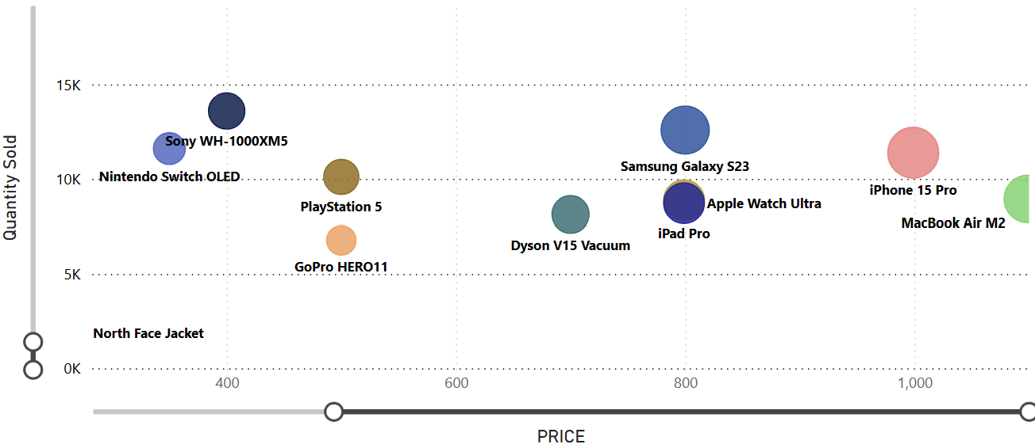

**Figure: 5**

1. **Balanced Mid-Range Performers**Mid-priced electronics such as the Galaxy S23 and Sony WH-1000XM5 strike a solid balance of price and volume, resulting in high revenue contribution.(refer figure 5)
2. **Clothing Segment Weakness**Clothing items like Puma Shorts and Zara Blazer show low price and low volume, with small bubble sizes. These indicate underperformance relative to other categories.

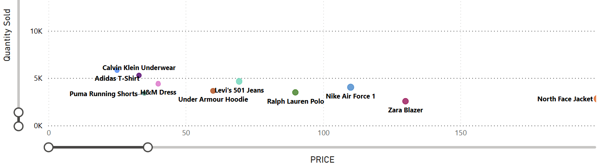

**Figure: 6**

### **Strategic Implications:**

* Price is not the sole factor in revenue generation—success lies in the right mix of price and volume.
* Focus on premium, high-margin electronics.  
  Improve visibility or pricing of clothing items.
* Grocery sales benefit from volume but need bundling or upselling to raise per-customer value.

## **Average Selling Price by Product Category**

The **average selling price (ASP)** varies significantly across product categories, highlighting clear differences in pricing strategy and customer purchase behavior.

* **Groceries** have the **lowest ASP at $4.67**, indicating a **high-volume, low-margin category** where revenue is driven by frequent purchases of lower-cost items.
* **Clothing** shows a **moderate ASP of $70.21**, suggesting a **mid-range pricing structure**, likely influenced by seasonal trends, brand variations, and promotional activity.
* **Electronics** stand out with a **high ASP of $684.61**, reflecting a **premium product category** where fewer items are sold, but each generates a significant amount of revenue.

These insights highlight how different categories contribute to the business — groceries through **volume**, clothing through **balanced pricing**, and electronics through **high-value purchases**.

Strategic Implications:

* Focus on **inventory turnover and promotions** in groceries to maintain volume and margins.
* In clothing, leverage **upselling (e.g., accessories)** and **seasonal campaigns** to boost ASP and units sold.
* For electronics, consider **extended warranties**, **bundling**, or **financing options** to maximize revenue per transaction.

## **Repeat Purchase Rate of Products**

This analysis explores **customer repeat purchase behavior** across three main product categories: **Grocery**, **Electronics**, and **Clothing**. The **repeat purchase rate** is a critical metric for understanding brand loyalty, product value perception, and customer satisfaction.

The data is visualized in a bar chart by product and category, with repeat purchase rates (%) represented on the Y-axis.

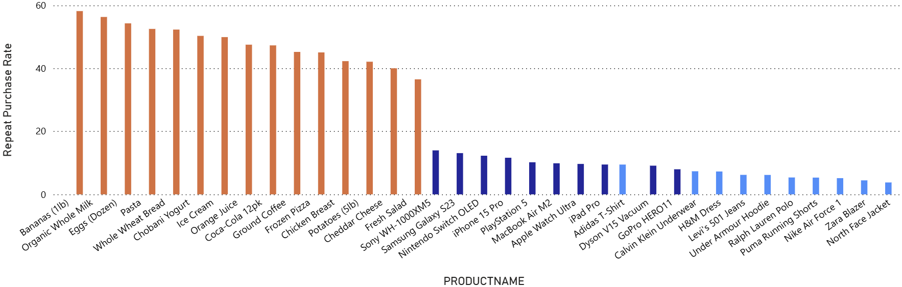

**Figure: 7**

### **Grocery – High Repeat Purchase Rates (42% to 58%)**

**Top Performers:**

* **Bananas (1lb)** – 58.19%
* **Organic Whole Milk** – 56.32%
* **Eggs (Dozen)** – 54.29%
* **Pasta, Whole Wheat Bread, Chobani Yogurt, Ice Cream** – all above 49%

**Insights:**

* Grocery dominates the top of the chart.
* These products are **essentials and frequently consumed**, explaining their high repeatability.
* Such high retention rates imply strong customer loyalty and opportunity for **cross-selling or bundling**.
* Products like **Ground Coffee, Frozen Pizza, Chicken Breast** also perform well (~42%-45%), indicating strong habitual buying behavior.

**Electronics – Moderate Repeat Purchase Rates (9%-14%)**

**Top Performers:**

* **Sony WH-1000XM5** – 14.00%
* **Samsung Galaxy S23** – 13.13%
* **Nintendo Switch OLED** – 12.30%

**Lower Repeat Rates:**

* **iPhone 15 Pro** – 11.65%
* **PlayStation 5** – 10.21%
* **MacBook Air M2, Apple Watch Ultra, iPad Pro** – between 9.5% and 10%

**Insights:**

* Electronics naturally have **lower repeat purchases** due to longer usage cycles and higher price points.
* However, values above 10% are **quite strong** for this category, indicating satisfaction and possible upgrade loyalty.
* Brand loyalty is evident for flagship products (e.g., Apple, Samsung).
* Opportunity exists for **upsell campaigns**, **accessory bundles**, and **extended warranty services**.

### 

### **Clothing – Low Repeat Purchase Rates (3%-9%)**

**Highest Repeat Rate:**

* **Adidas T-Shirt** – 9.49%

**Lower-End Products:**

* **North Face Jacket** – 3.79%
* **Zara Blazer** – 4.46%
* **Nike Air Force 1, Puma Shorts, Ralph Polo, H&M Dress** – between 5% and 6.5%

**Insights:**

* Clothing items show the **lowest repeat engagement**, likely due to being **fashion-dependent**, **seasonal**, and **less frequently replenished**.
* This indicates a **need for better re-engagement strategies**, like:
  + Personalized recommendations
  + Seasonal drops
  + Loyalty rewards
  + Limited-time discounts

| **Category** | **Avg. Repeat Rate** | **Loyalty Insight** | **Strategic Suggestions** |
| --- | --- | --- | --- |
| **Grocery** | 45-58% | High loyalty, frequent use | Focus on bundles, loyalty rewards |
| **Electronics** | 9-14% | Moderate loyalty (for high-cost items) | Promote upgrades, trade-ins, accessories |
| **Clothing** | 3-9% | Low loyalty, style/season sensitive | Use trends, retention offers, personalization |